THIS IS THE SQL WORK WHICH IS USED IN LIBRARY MANAGEMENT SYSTEM

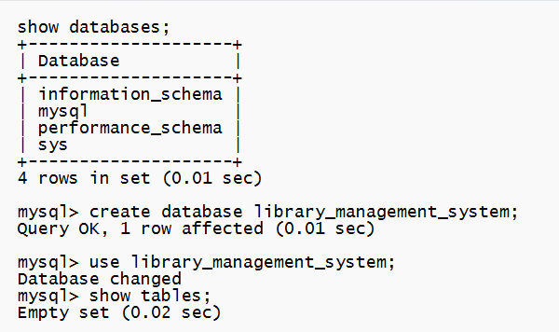

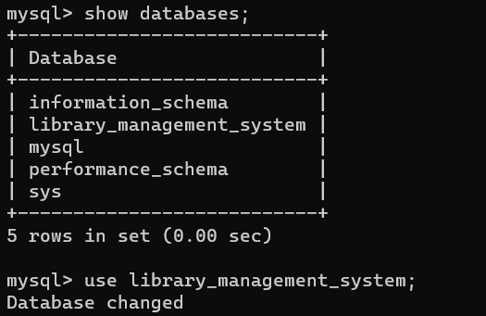

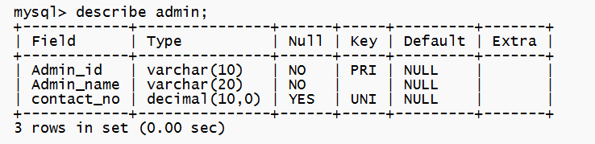

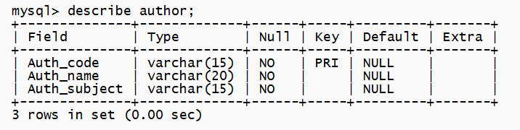

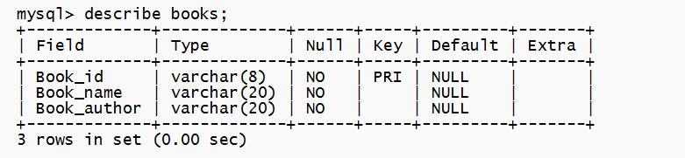

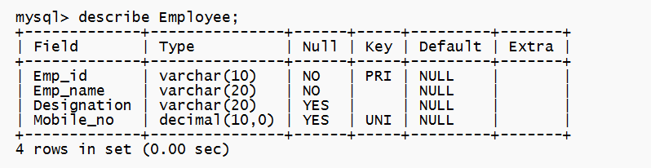

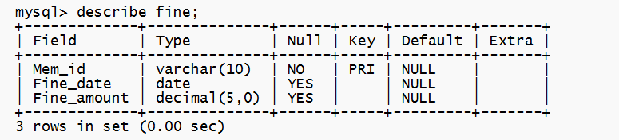

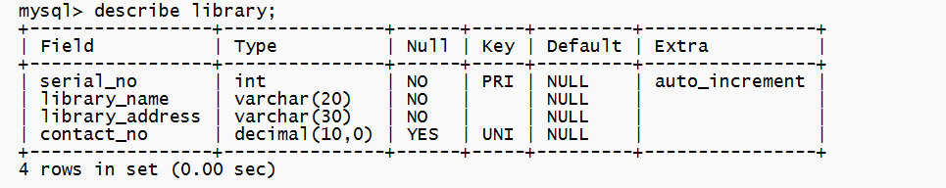

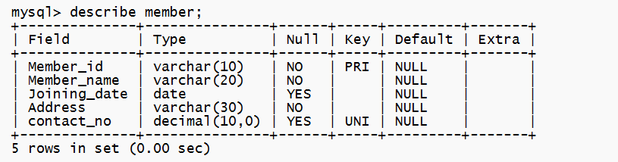

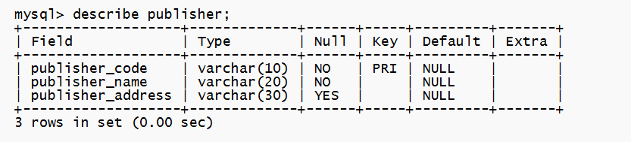

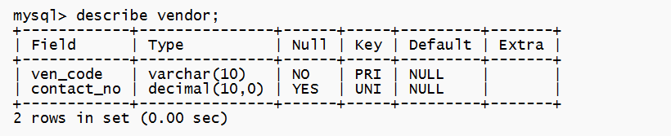

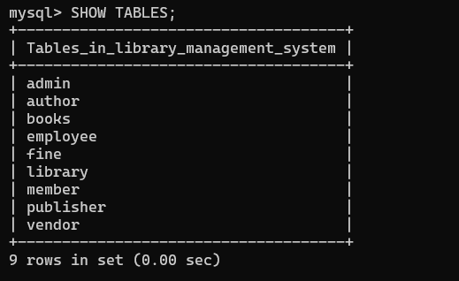

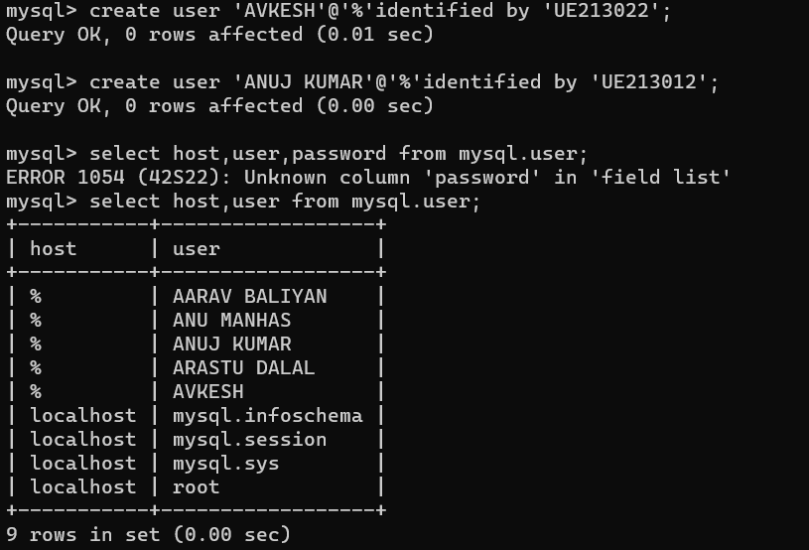

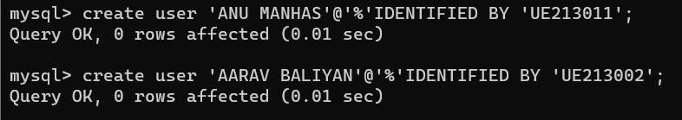

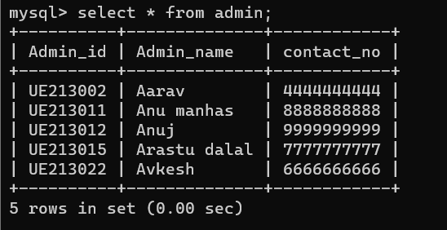

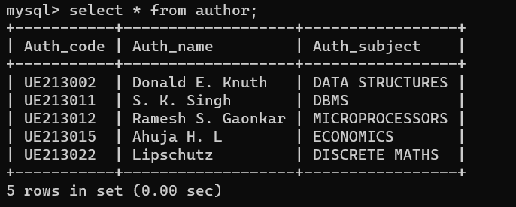

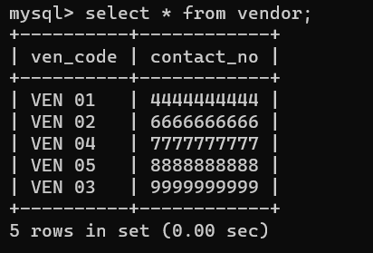

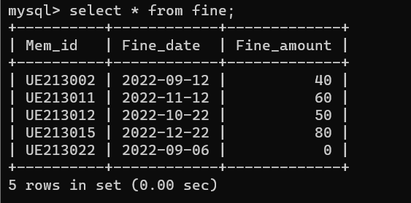

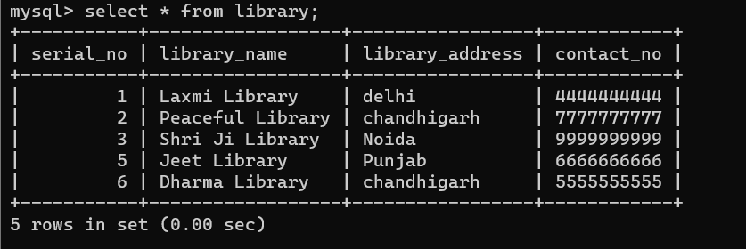

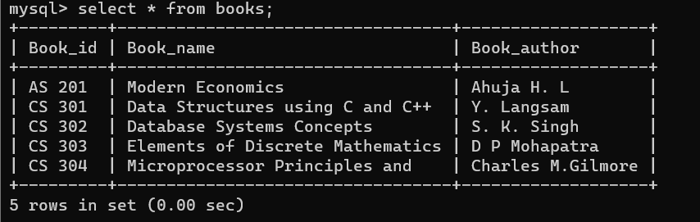

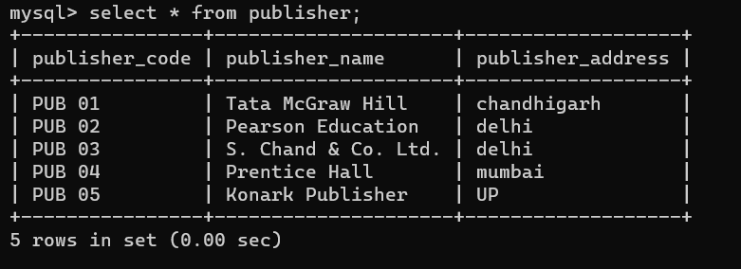

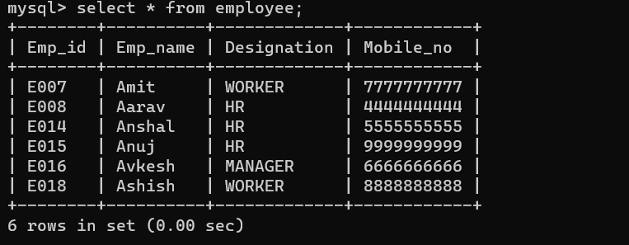

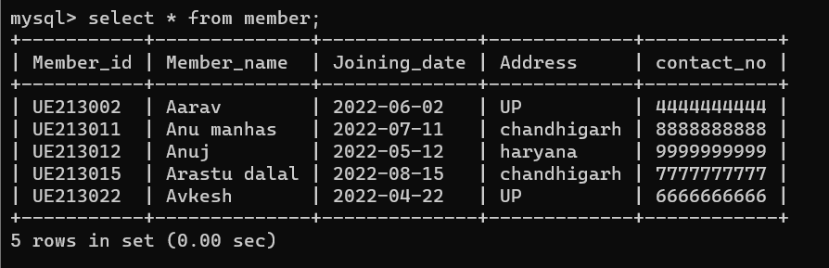

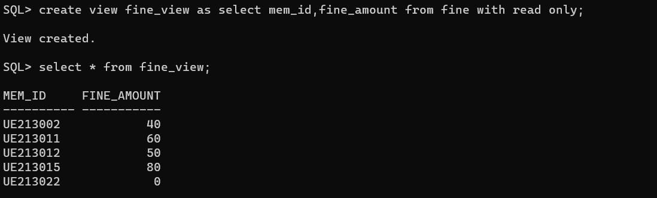

CURSORS

1. CURSORS FOR FINDING TOP 3 HIGEST MEMBER HAVING HIGEST FINE

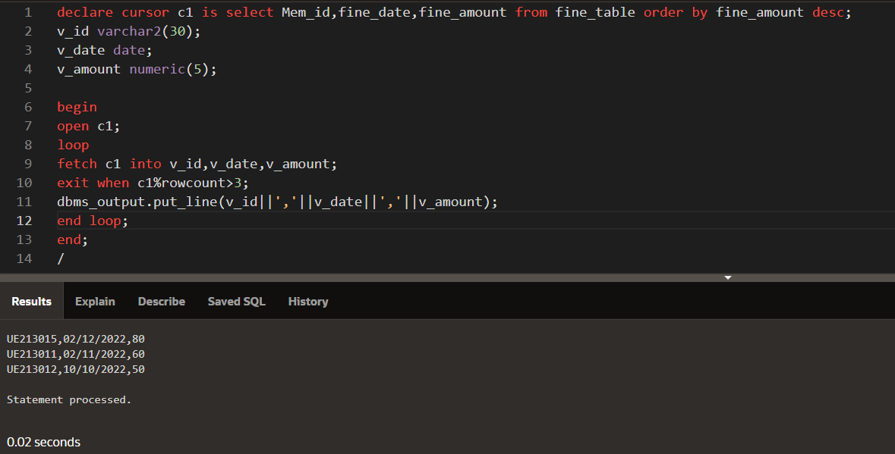

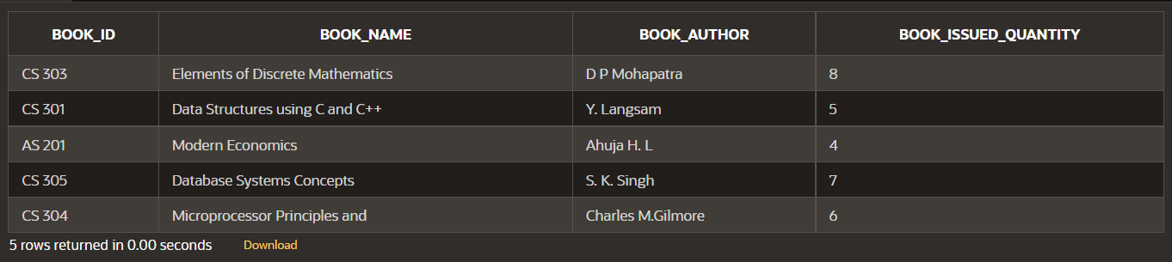

2. CURSORS FOR FINDING TOP 3 HIGEST ISSUED BOOKS

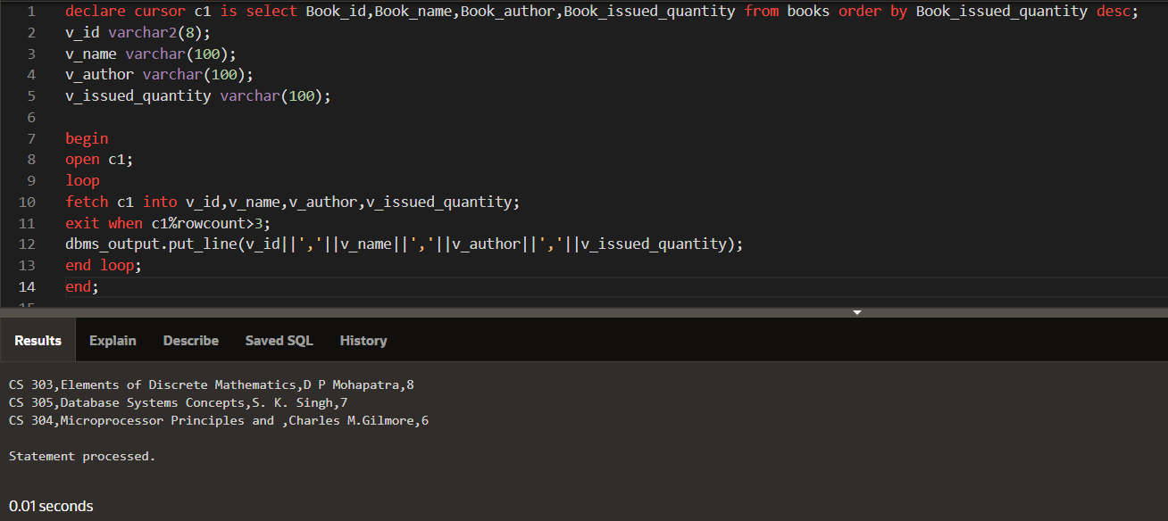

TRIGGERS

1. DATABASE LOGIN TRIGGER

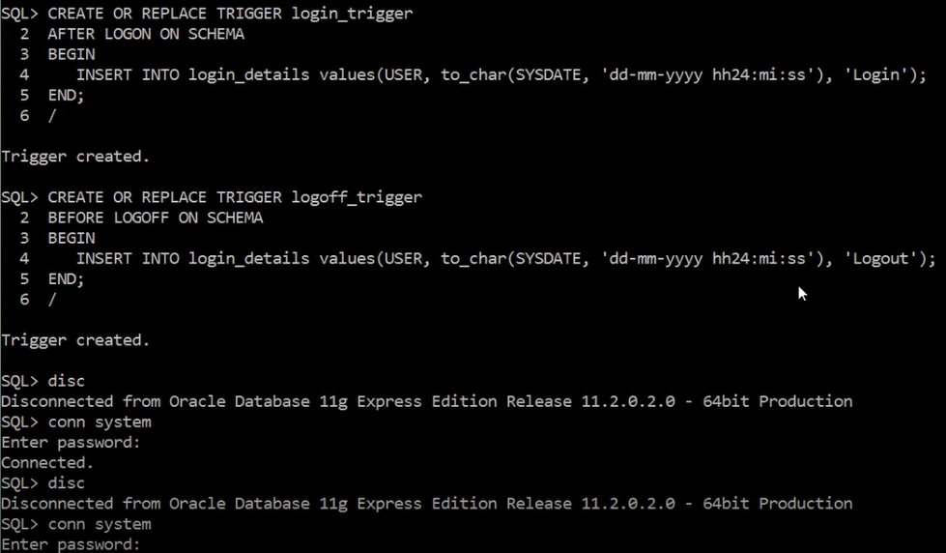

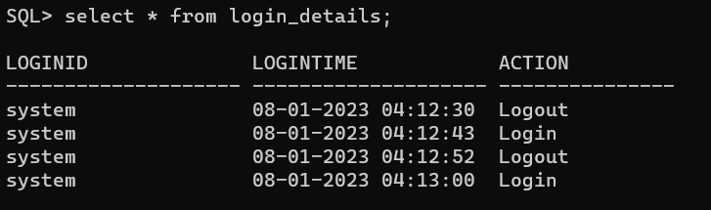

1. /* Day & Time Check Trigger – With User Defined Exception */

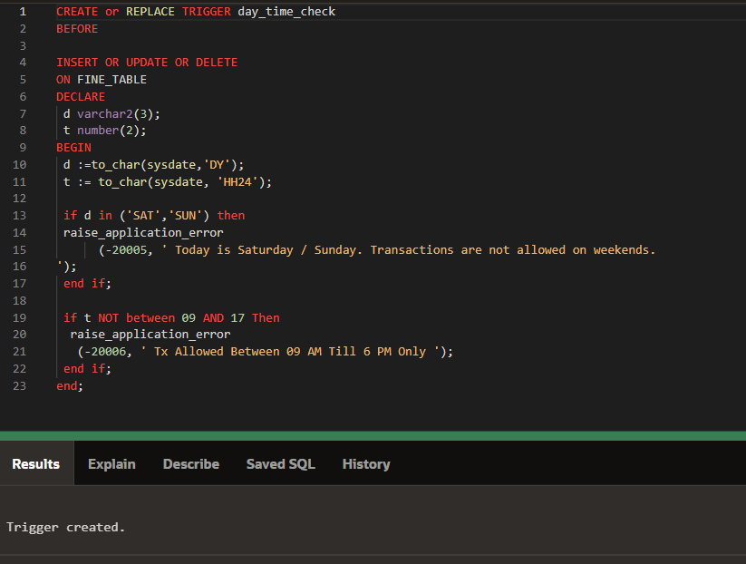

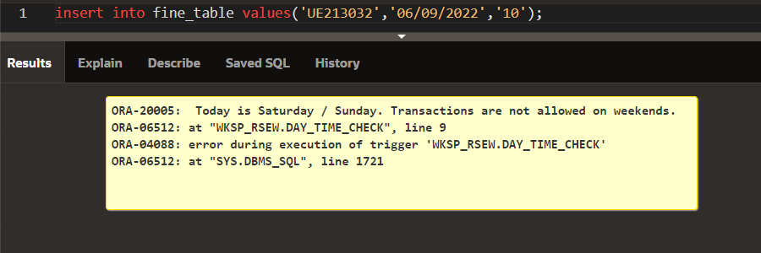

3. /*FINE Backup Trigger */

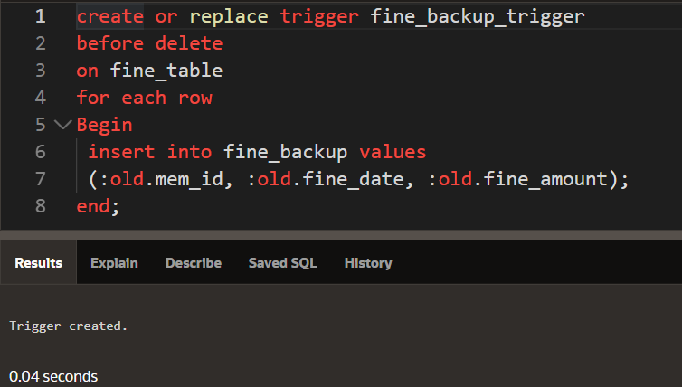

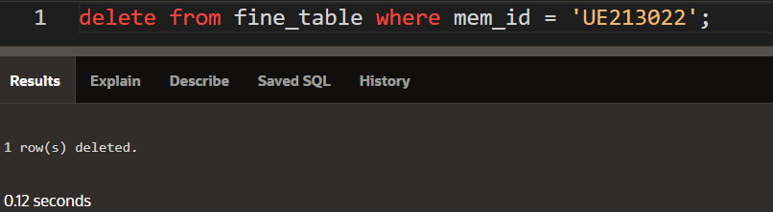

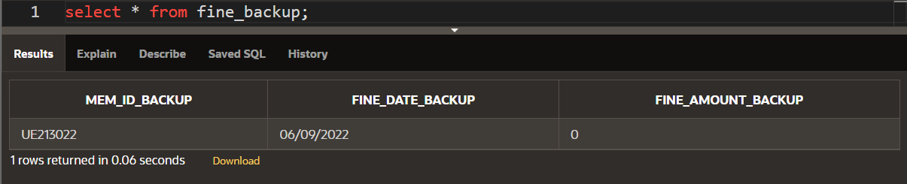

4. /* fine Check Trigger – With User Defined Exception */

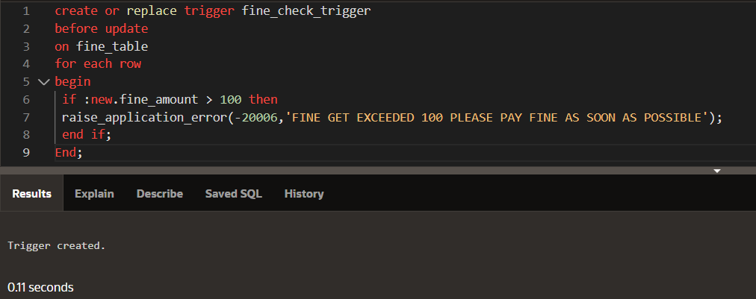

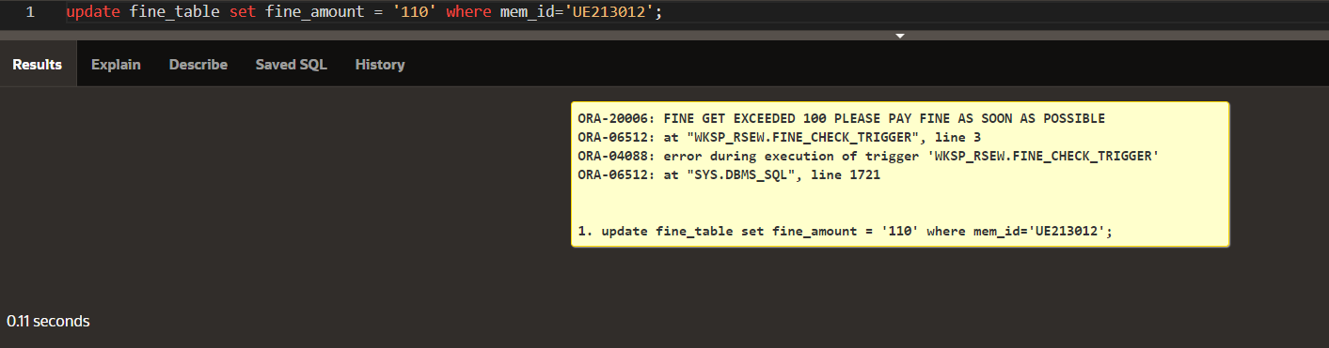

*********************PUBLISHER TABLE*****************************

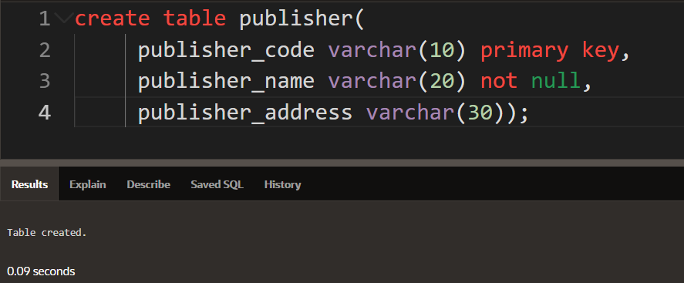

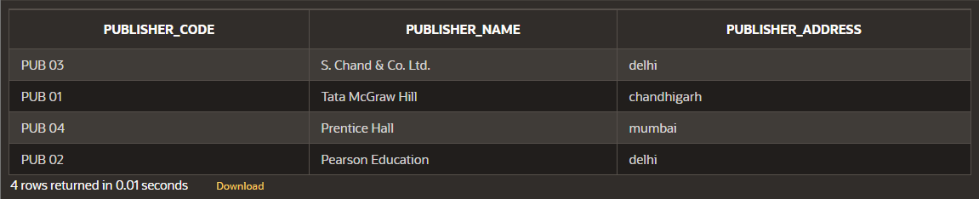

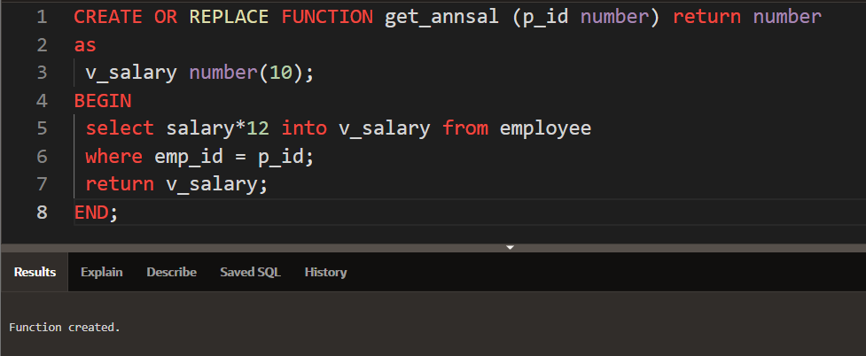

***********************************PROCEDURE***********************************

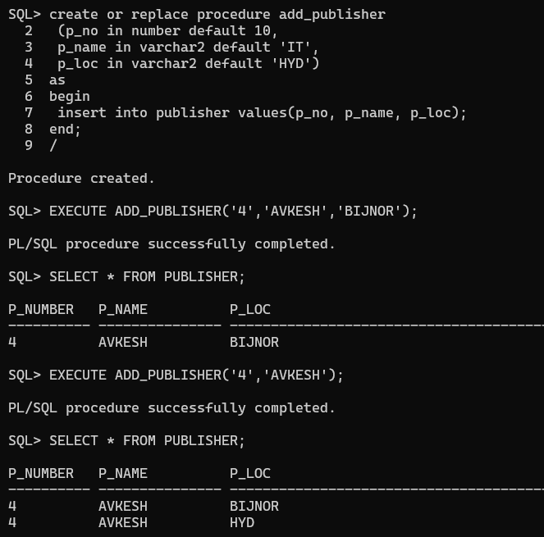

BEFORE ADDING EMPLOYEE THROUGH PROCEDURE

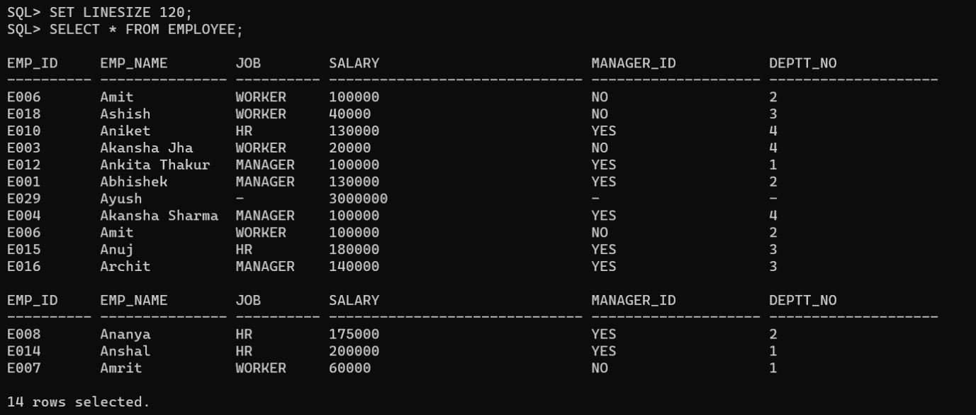

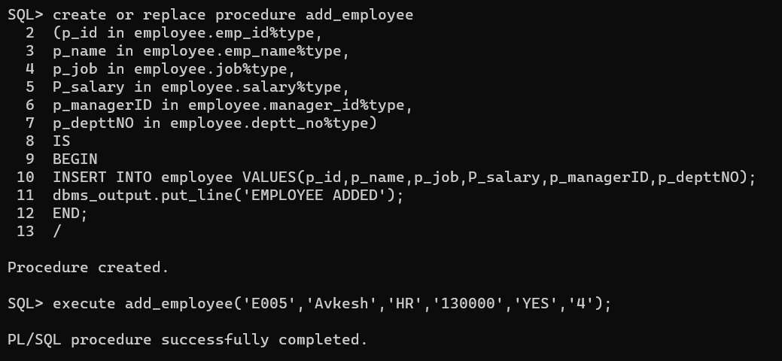

AFTER ADDING EMPLOYEE THROUGH PROCEDURE

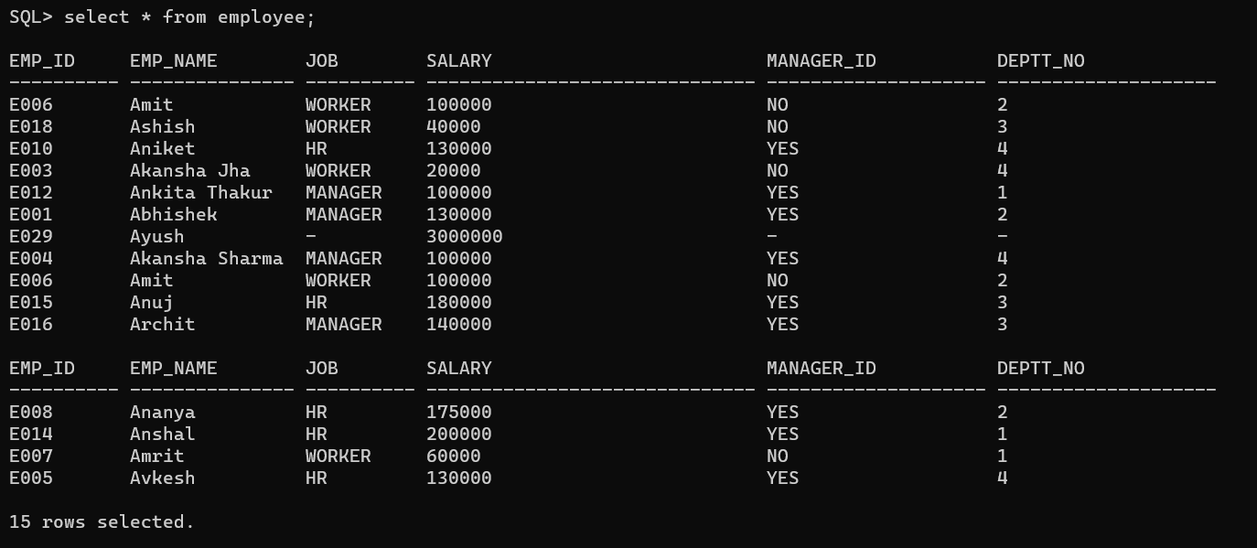

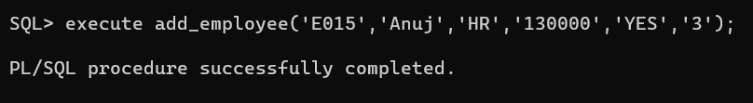

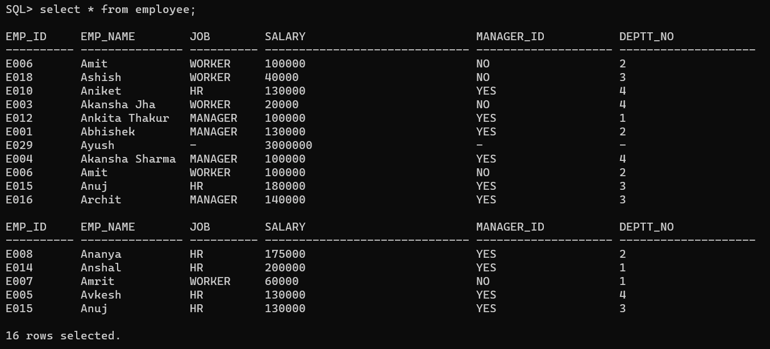

FUNCTION

1.

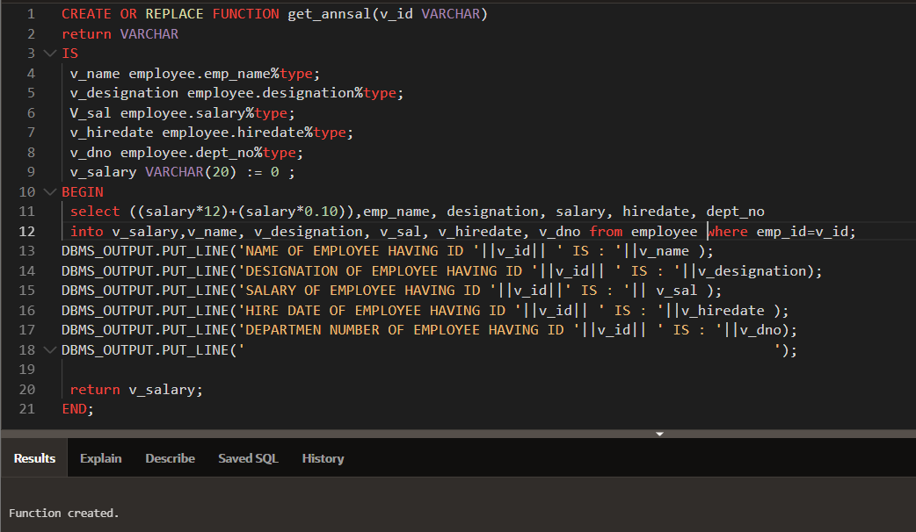

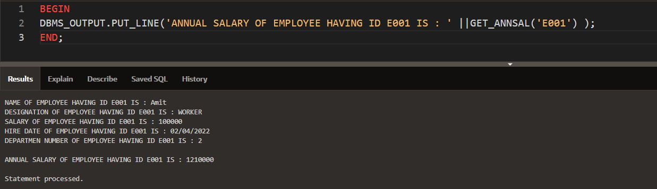

2.

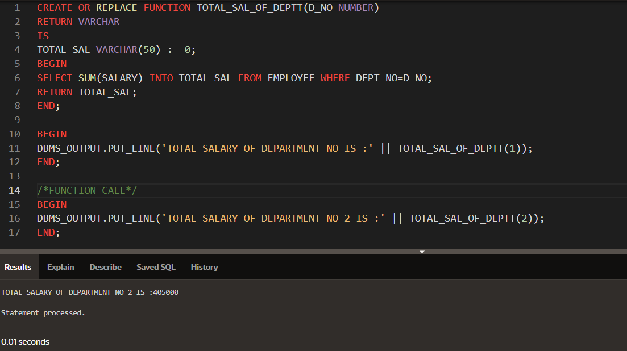

3.

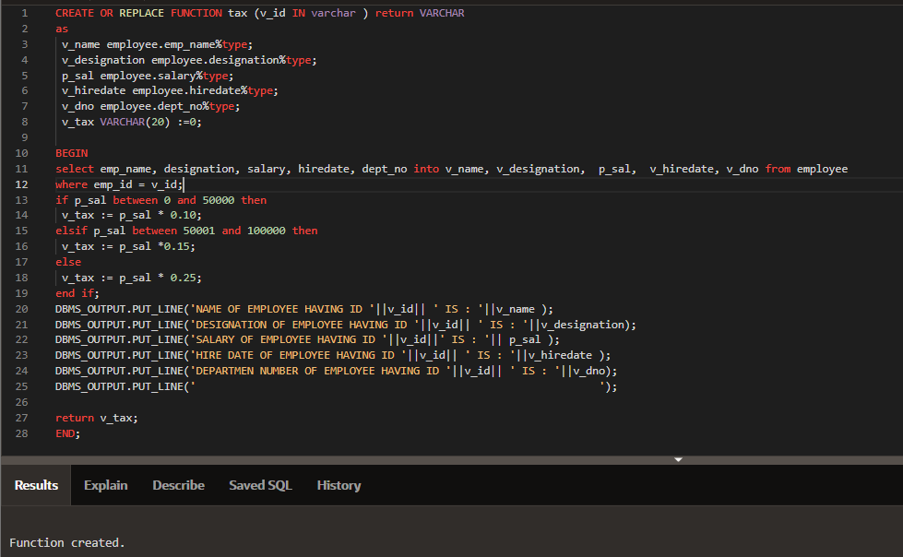

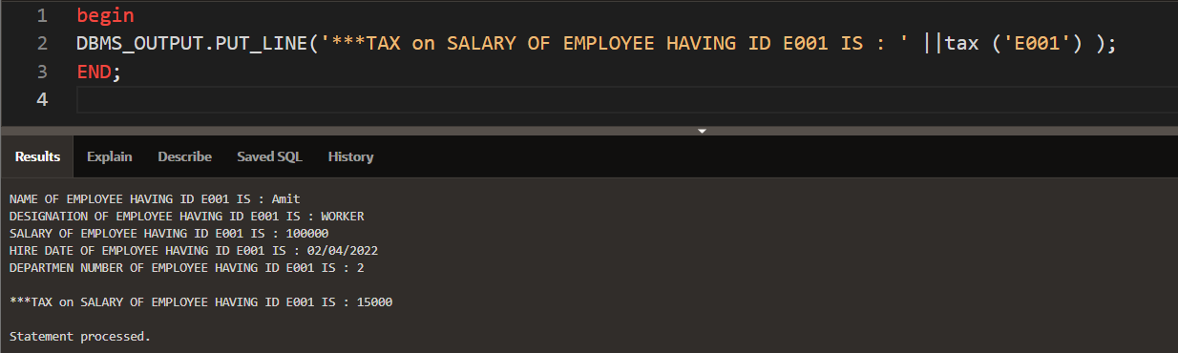

4.

FUNCTION CALL:

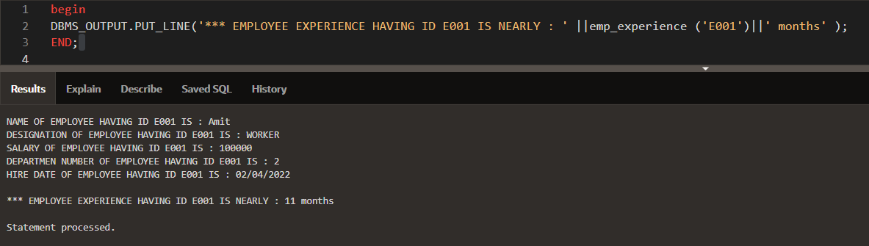

***********************EXCEPTION HANDLING************

PRE DEFINED EXCEPTION

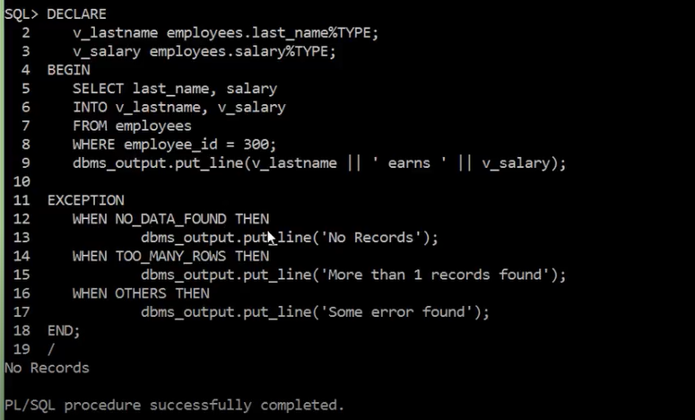

USER DEFINED EXCEPTION

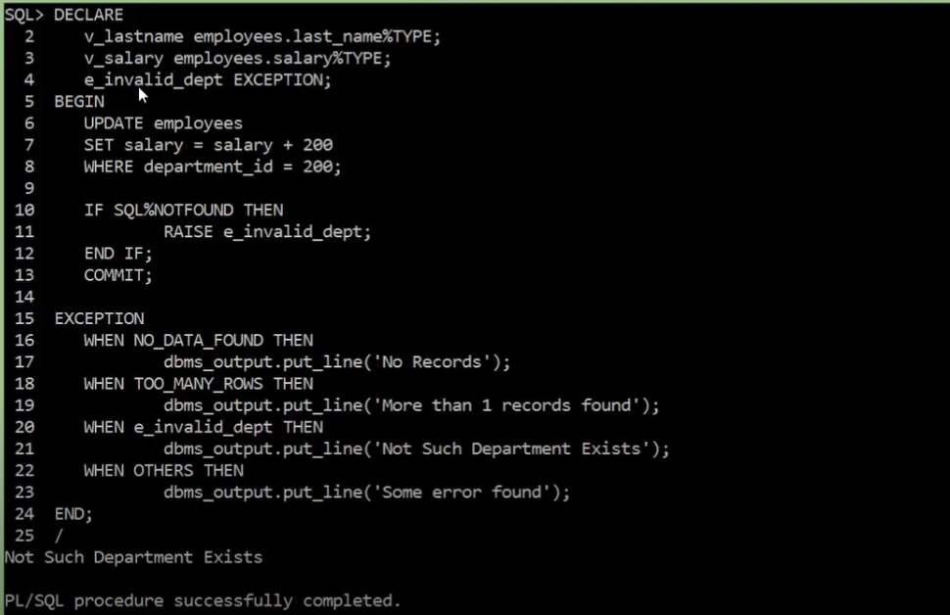

********************************PACKAGES*****************************************

ALL_OPERATION PACKAGE SPECIFICATION FOR LIBRARY_TABLE:

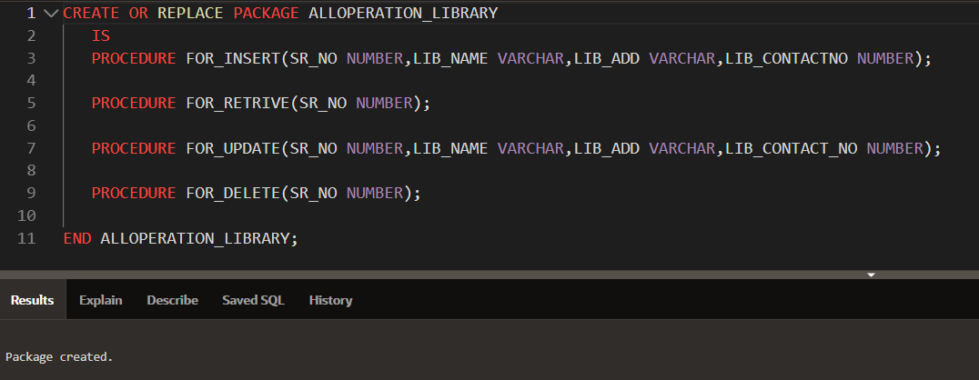

ALL_OPERATION PACKAGE BODY FOR LIBRARY_TABLE:

CALLING ALL_OPERATION PACKAGE FOR LIBRARY_TABLE:

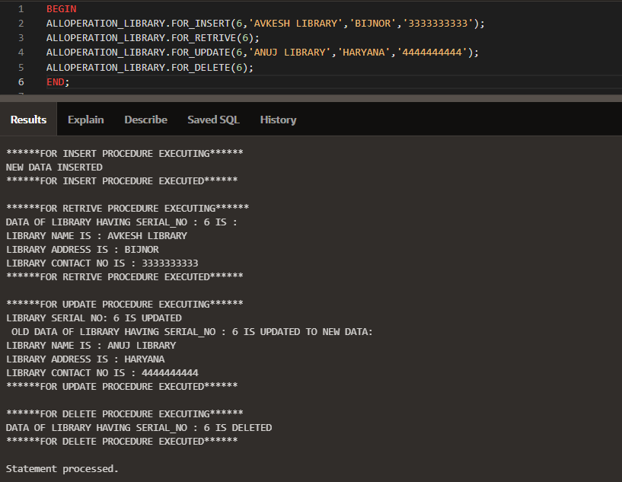

2.

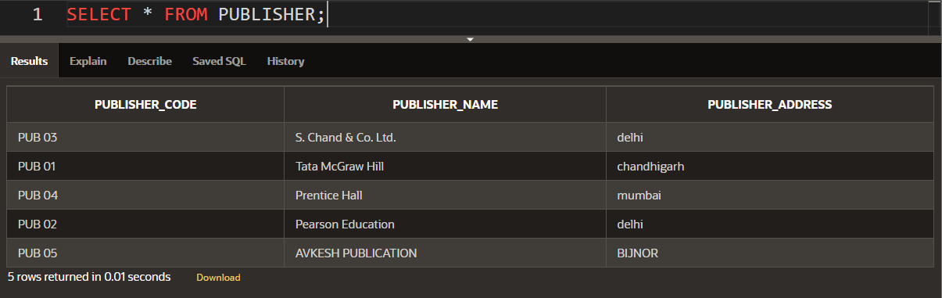

PACKAGE SPECIFICATION:

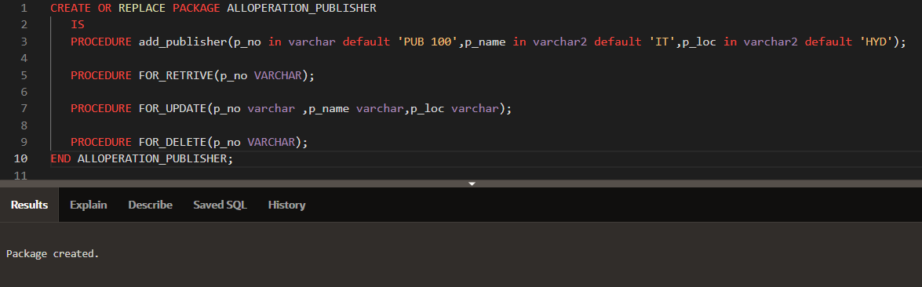

PACKAGE BODY:

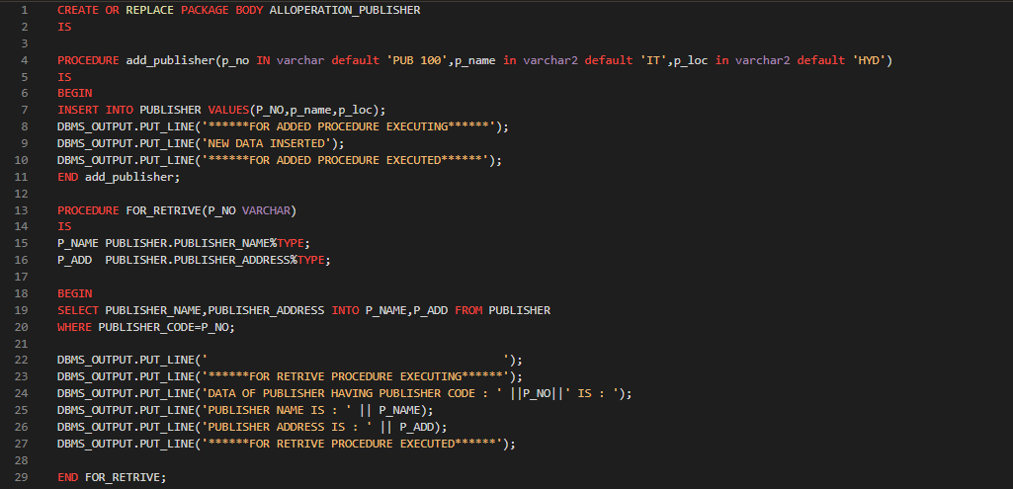

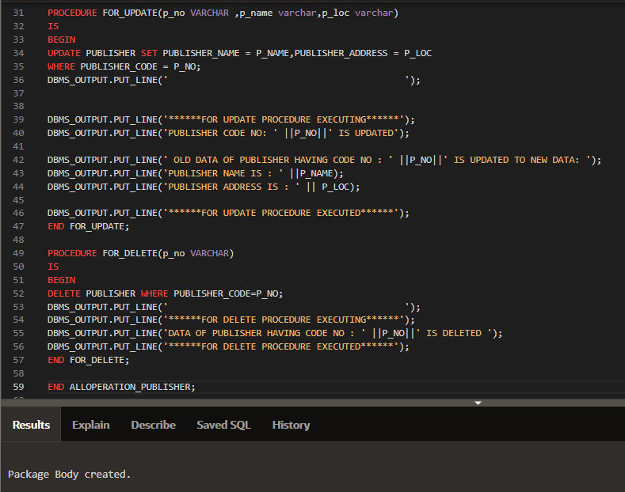

PACKAGE CALL:

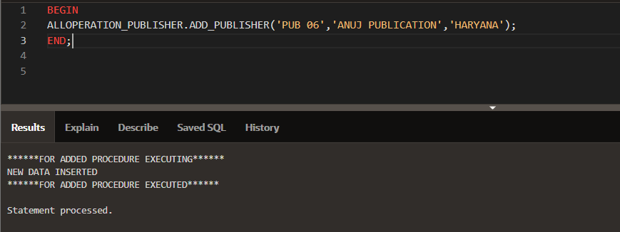

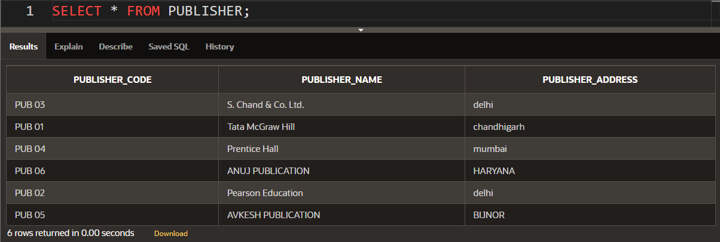

3.

BEFORE:

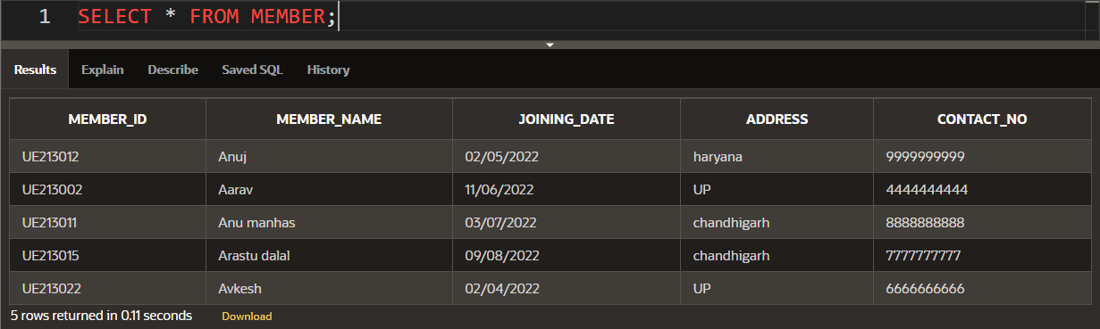

PACKAGE SPECIFICATION:

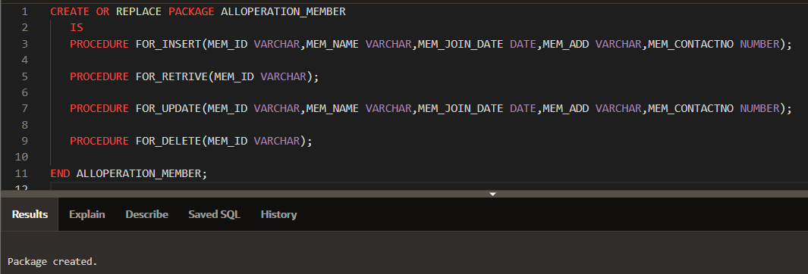

PACKAGE BODY:

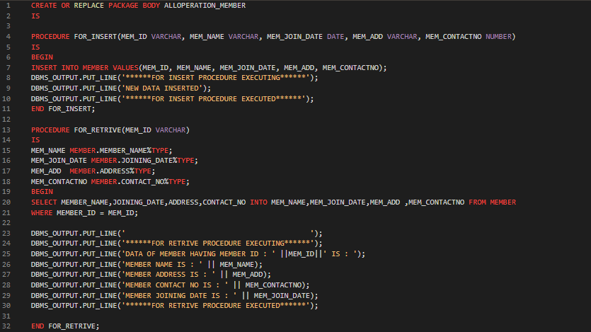

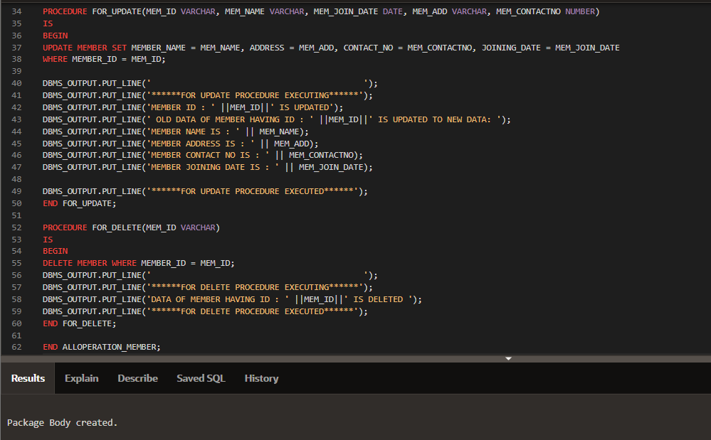

PACKAGE CALL

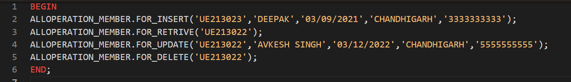

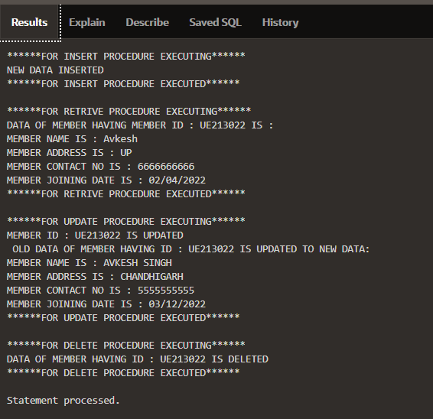

AFTER :

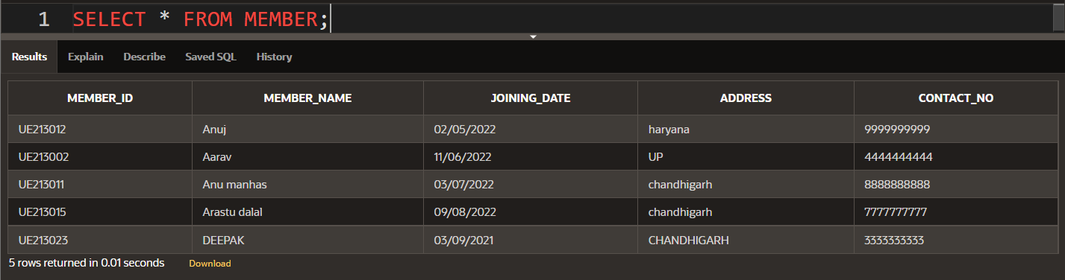

************************EMPLOYEE MANAGE PACKAGE***************************

SPECIFICATION***********************

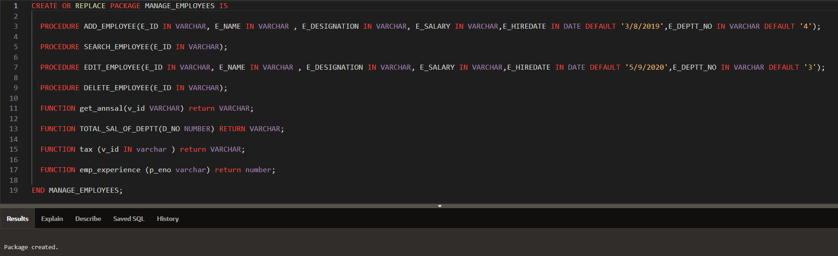

PACKAGE BODY************

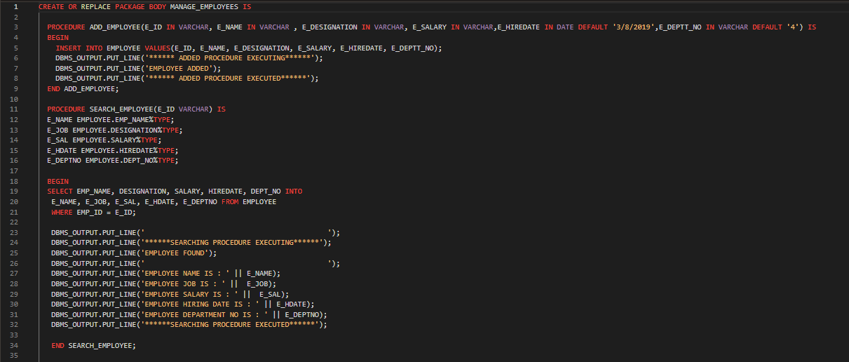

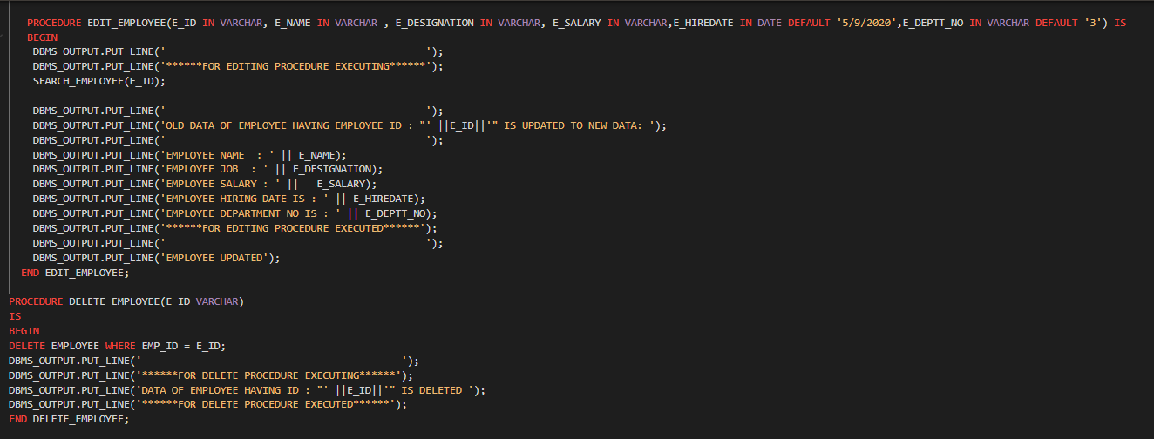

PACKAGES FUNCTION INSIDE BODY :

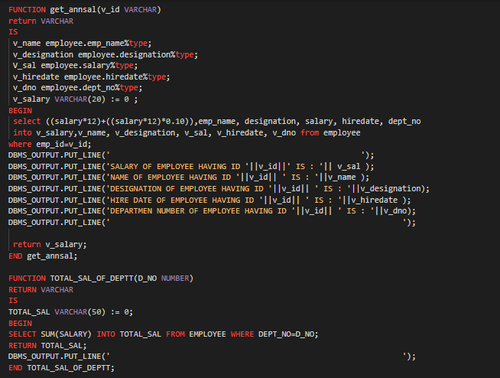

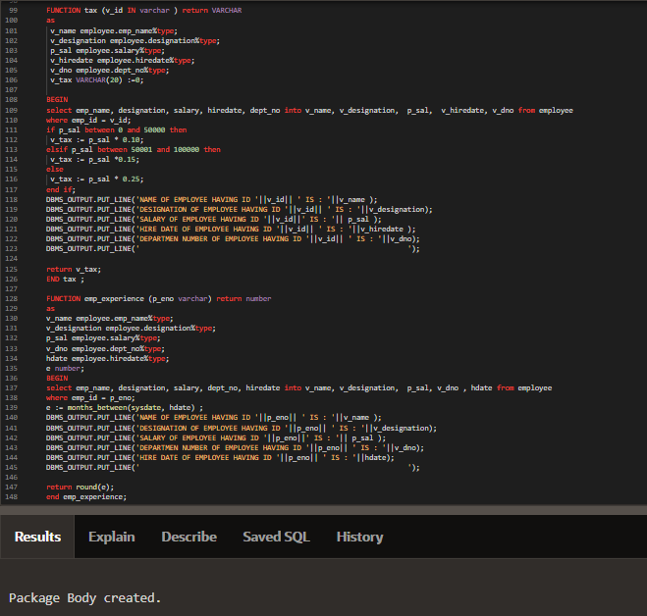

PACKAGE CALL:

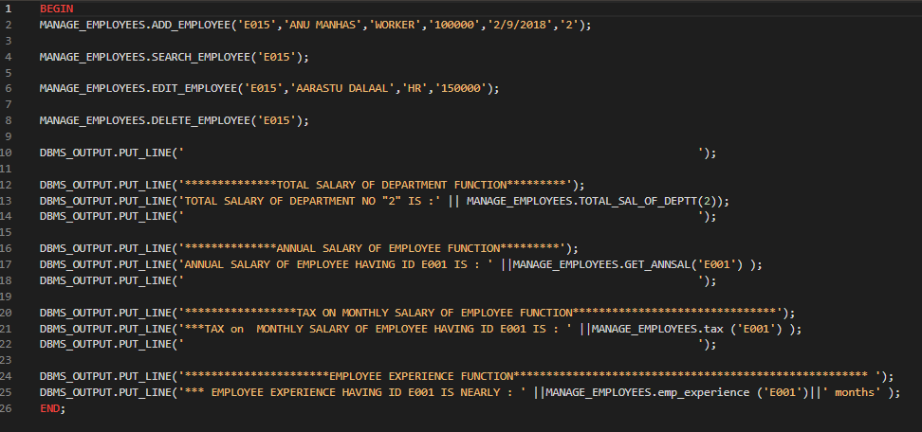

OUTPUT OF PACKAGE:

